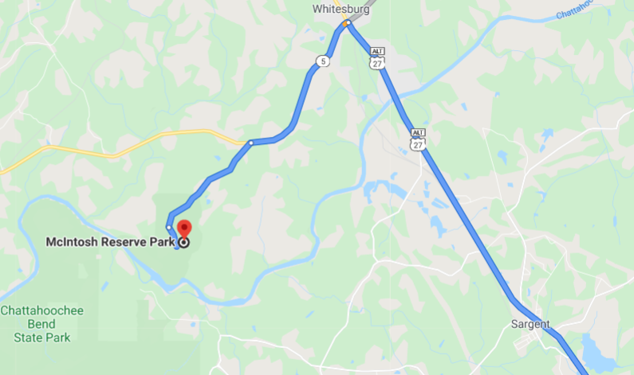

McIntosh Reserve Park
1046 W McIntosh Circle
Whitesburg, GA 30185
27 miles from Cokes Chapel

